Teacher dashboard

**Home video lectures study material Take Test My Sessions My students** **My profile/ logout**

**My students**

**Student profile**

**Message Session History Schedule Class**

Subject Grade

Topic

Date and time

**Schedule the class**

On teacher home page

Teacher dashboard

**Home video lectures study material Take Test My Sessions My students** **My profile/ logout**

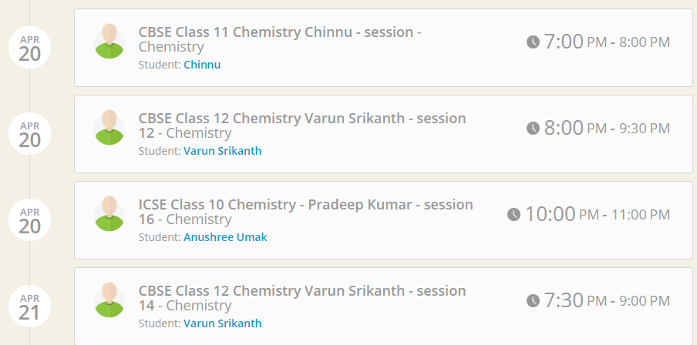Teacher home page will be having MY SESSIONS like this example with date and time

**Cancel session Reschedule session**

**Cancel session Reschedule session**

**Cancel session Reschedule session**

At right time the JOIN session should get activated like this

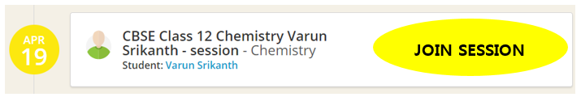

**Session will expire at the given time**

**Can also be ended by teacher any time (with end session button on white board)**

**And**

**When the session ends**

Message will be displayed at both side (teacher and student) like

**Get session Recording**

**Skip**